Task Bag #_____: Alphabet Puzzle
Contents:
- Alphabet puzzles
Target Skills: Readiness – Alphabet Exploration/Fine Motor
“I can find the letters in my name.”
“I can say the letter names.”
“I can say the letter sounds.”
“I can match by color/shape/etc.”
Vocabulary to use with student:
Alphabet
Letters (and sounds)
Find
Puzzle

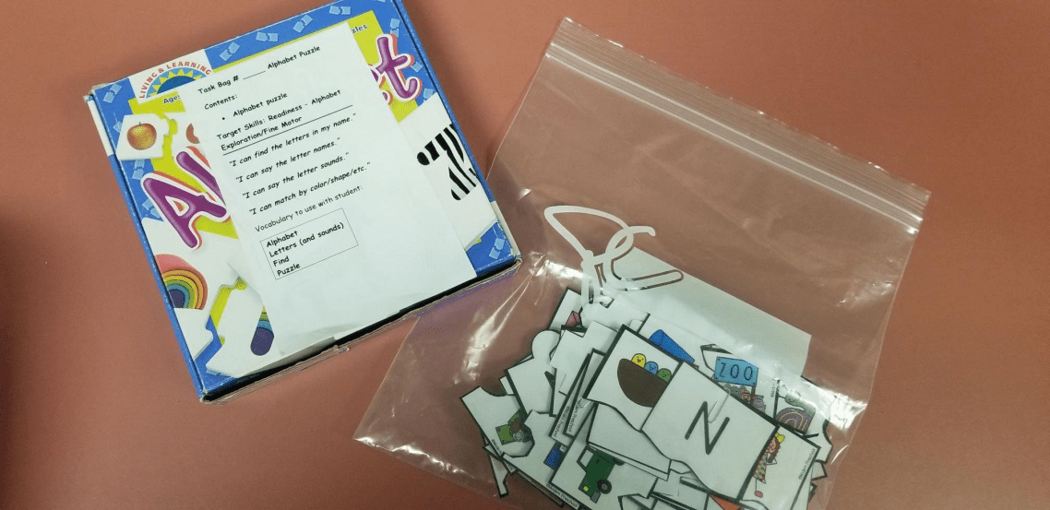
*These task bags can be used individually or in a small group with an Educational Assistant or caregiver. While the task bags are not in a digital format, materials and instructions can be sent home for further practice.
Task Bag #_____: Bean Letter Find
Contents:
- Tub of beans
- Duplo blocks with alphabet letters and sound pictures
Target Skills: Readiness – Alphabet Exploration/Sensory Play
“I can find the letters in my name.”
“I can say the letter names.”
“I can say the letter sounds.”
“I can tolerate different textures.”
Vocabulary to use with student:
Alphabet
Letters (and sounds)
Find
Beans
Yellow
Green
Red

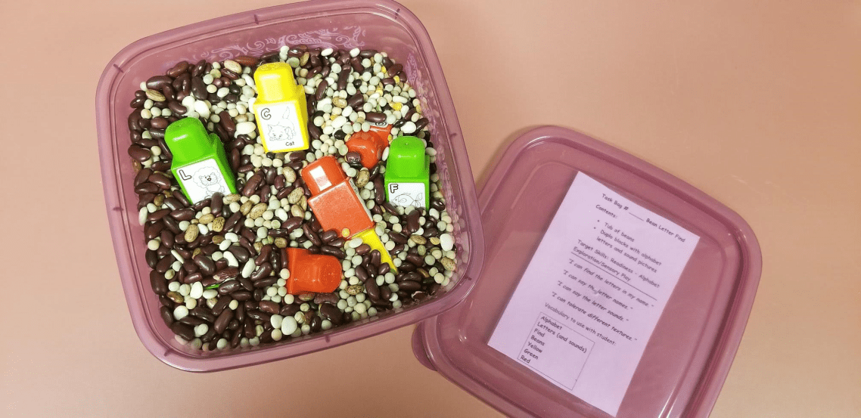

Task Bag #_____: Mr. Potato Head
Contents:
- Mr. Potato Head
- Potato head parts
- Body parts puzzle
Target Skills: Language Arts - Vocabulary
“I can name parts of the body.”
“I know where my body parts are.”
“I can tell about body parts.”
Vocabulary to use with the student:
Head
hand
tummy
arm
leg
foot

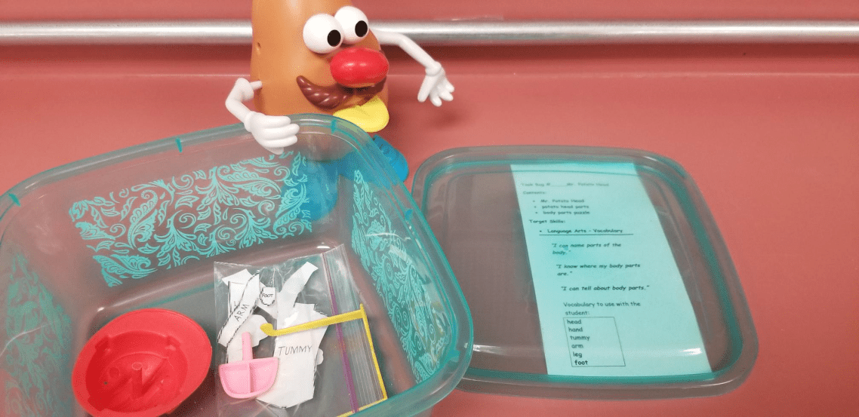

Task Bag #_____: Playdough Alphabet
Contents:
- Laminated alphabet templates
- Playdough x2
Target Skills: Readiness – Alphabet Writing/Fine Motor Play
“I can create the letters in my name.”
“I can use playdough to form letters.”
“I can name the letters.”
Vocabulary to use with student:
Alphabet
Letters
Playdough
Create

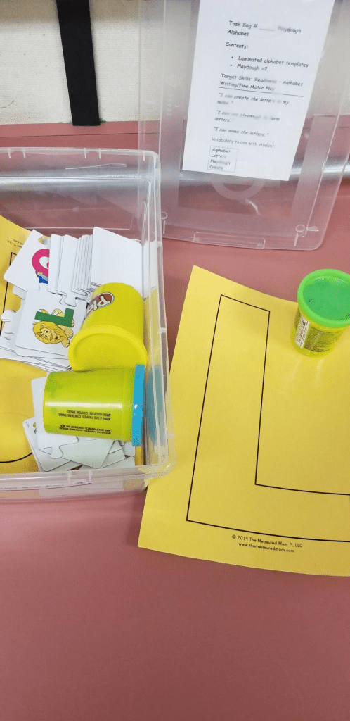

Task Bag #_____: Shaving Cream Alphabet
Contents:
- Lid/tin for drawing
- Paint brush for forming letters
- Shaving cream bottle
Target Skills: Readiness – Alphabet Writing/Sensory Play
“I can tolerate different textures and smells.”
“I can use shaving cream to form letters.”
“I can say the letters in my name.”
“I can name the letters.”
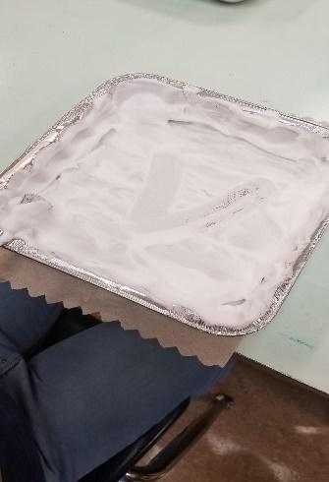
Vocabulary to use with student:
Alphabet
Letters
Shaving Cream
Create

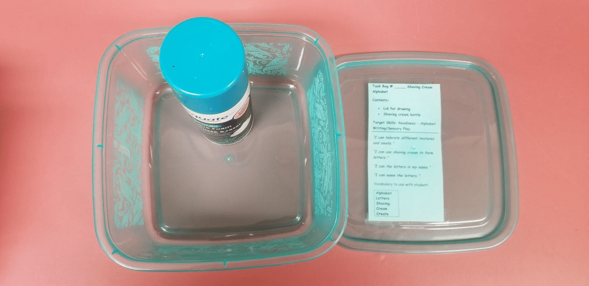

Task Bag #_____: Story Sequencing
Contents:
- Story sequencing cards
Target Skills: Concepts of Print/Story Sequencing
“I can sequence 3 picture cards to tell a story.”
Vocabulary to use with student:
First
Next
Last
Story

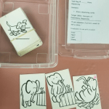

Task Bag #_____: Fine Motor Cutting and Tracing
Contents:
- Tracing and cutting sheets
- Pencils/scissors
Target Skills: Fine Motor – Writing Readiness
“I can use the pincer grip to grab a pencil and/or scissors.”
“I can use the tripod grasp to trace over lines.”
“I can use scissors to cut.”
“I can turn the page when cutting with my non-dominant hand.”
Vocabulary to use with the student:
Cut/Snip
Trace/Write
Pencil
Scissors
Turn
Grab
Close

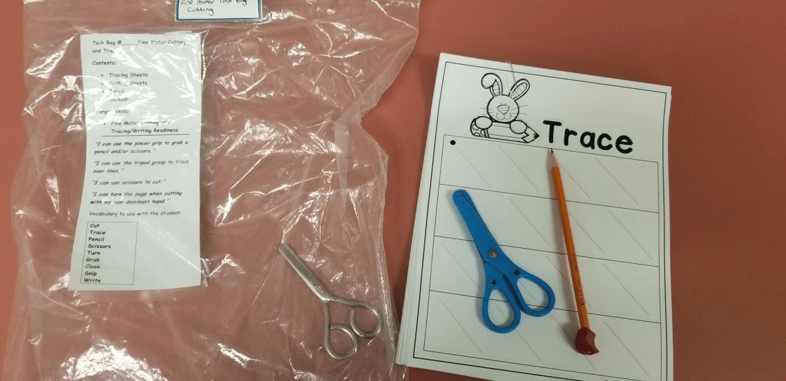
Task Bag #_____: Fine Motor Hole Punch
Contents:
- Coloured foam
- Hole punch
Target Skills: Fine Motor
“I can punch holes.”
“I can state the colors.”
Vocabulary to use with student:
Red
Yellow
Orange
Green
Blue
Pink
Hole Punch

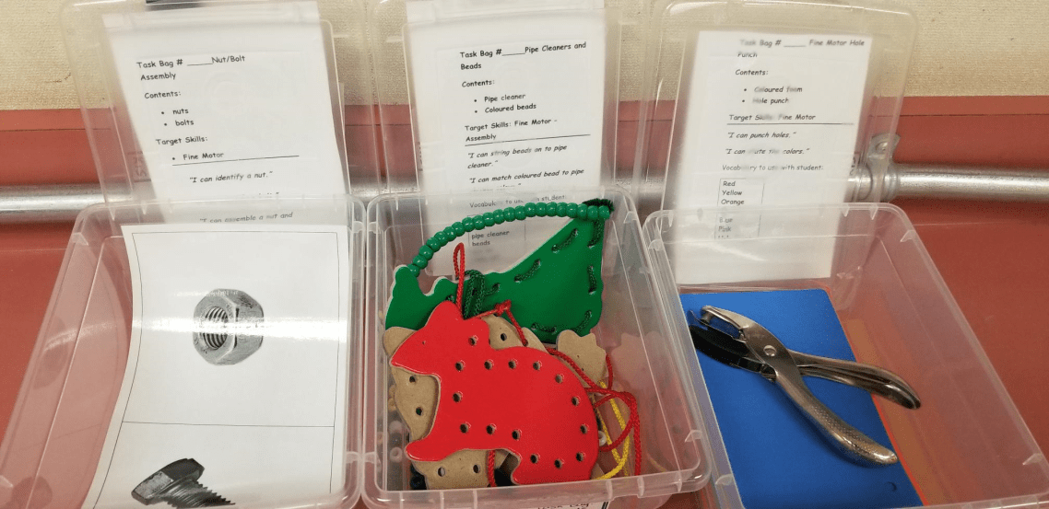

Task Bag #_____: Fine Motor Pick Up
Contents:
- Pom-poms
- Tweezers
- Small container
Target Skills: Fine Motor
“I can use a pincer grip to open and close tweezers.”
“I can use tweezers to pick up pom-poms and transfer to a container.”
Vocabulary to use with student:
Pom-pom
Tweezers
Pick up
Put
Red
Black

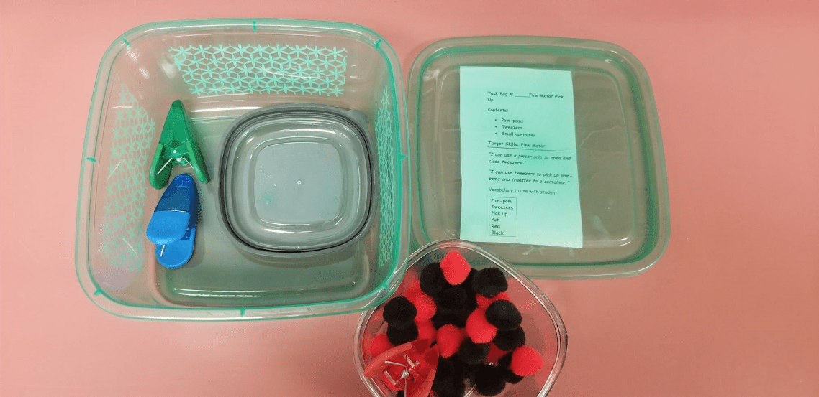

Task Bag #_____: Fine Motor Pull
Contents:
- Spools
- Container
Target Skills: Fine Motor Control
“I can use the pincer grip to pull a spool from a surface.”
“I can a pincer grip to place a spool into a small opening.”
Vocabulary to use with the student:
Pull
Put
In
Off
Red
Yellow
Green
White
Blue
Spool

Task Bag #_____: Fine Motor Push
Contents:
- 2 small containers
- Coloured pom-poms
Target Skills: Fine Motor Push
“I can use a pincer grip to pick up pom-poms.”
“I can use my pointer finger to push the pom-poms into a container.”
Vocabulary to use with student:
Pom-poms
Push
Pick up
Green
Blue
Orange
Purple
White
Pink
Yellow
Red
Black

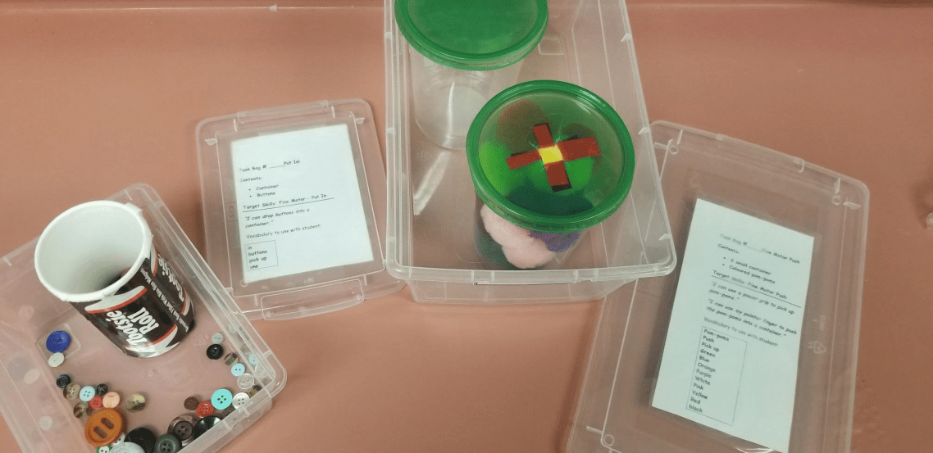

Task Bag #_____: Fine Motor Put In
Contents:
- Container
- Buttons
Target Skills: Fine Motor – Put In
“I can drop buttons into a container.”
“I can use a pincer grip to grab and put-in.”
Vocabulary to use with student:
in
buttons
pick up
one

Task Bag #_____: Puzzles
Contents:
- Puzzles
Target Skills: Fine Motor/Visual
“I can put a puzzle together.”
“I can match by size, color, number, and shape.”
Vocabulary to use with student:
Puzzle
Match
Count

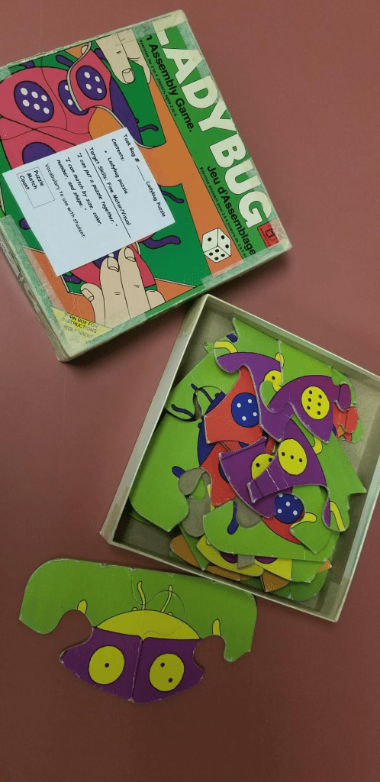

Task Bag #_____: Shape Puzzle
Contents:
- Orange container with blue shape lid
- Corresponding shapes
Target Skills: Matching Shapes/Fine Motor Drop-In
“I can match based on shape.”
“I can name the shapes.”
“I can drop items into a container.”
Vocabulary to use with student:
Drop-in
Heart
Flower
Circle
Triangle
Square Small
Big
Medium

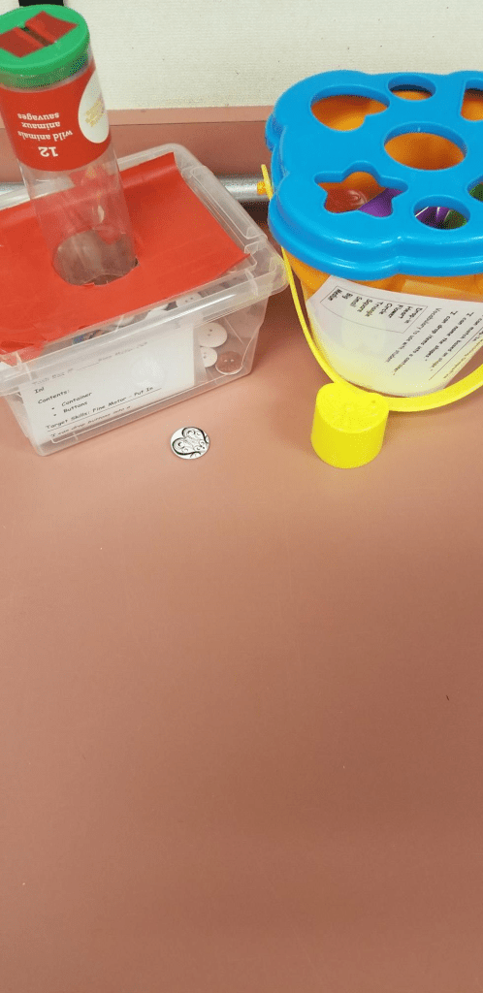
Task Bag #_____: Wiki Sticks
Contents:
- White board with wiki shapes
- Markers
- Eraser
Target Skills: Fine Motor – Coloring
“I can colour within a boundary.”
“I can match colours.”
Vocabulary to use with the student:
circle
square
triangle
rectangle
diamond
heart
green
red
black
colour
inside
boundary

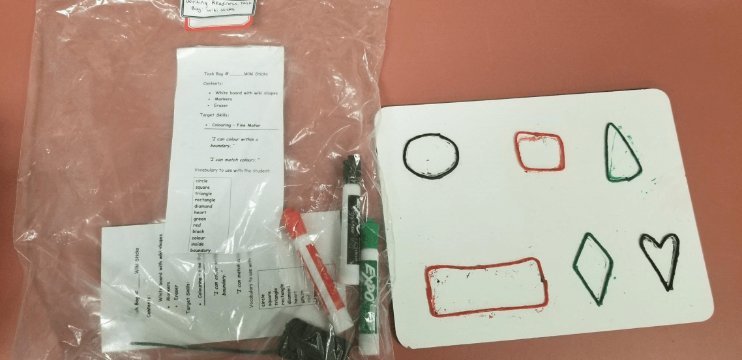

Task Bag #_____: Zippers, Buttons, and Laces
Contents:
- Zipper practice board
- Button practice board
- Laces practice board
- Shoes, coats, shirts, etc.
Target Skills: Functional Life Skills/Dressing
“I can zip a zipper.”
“I can button a shirt.”
“I can tie my shoes.”
Vocabulary to use with student:
Zip
Zipper
Button(s)
Tie
Laces
Shoes
Shirt
Jacket
Pants

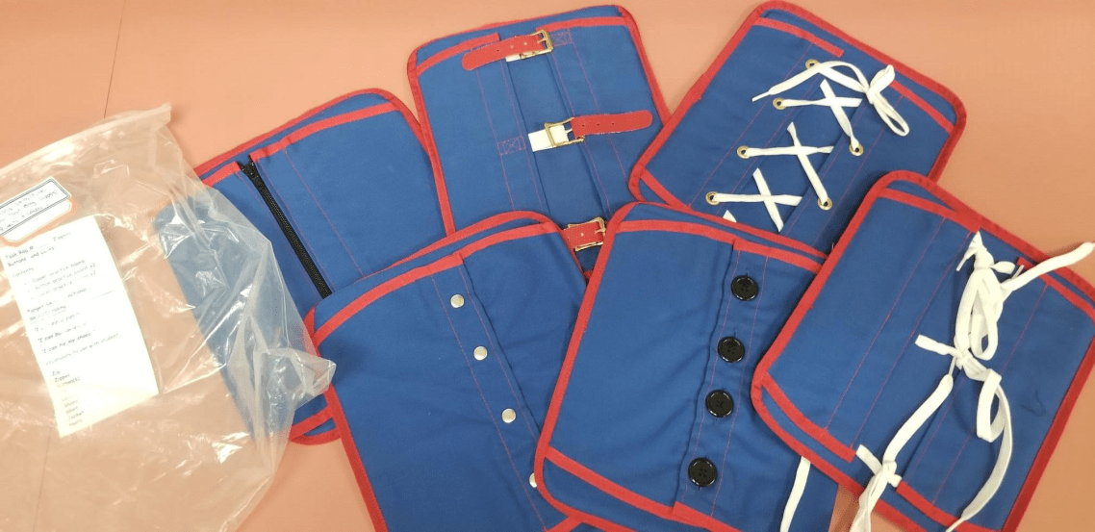
Task Bag #_____: Flashlight Assembly
Contents:
- Flashlight
- Batteries
Target Skills: Fine Motor/Life Skills
“I can identify proper battery insertion.”
“I can assemble a flashlight and turn it on.”
Vocabulary to use with student:
Flashlight
Battery
End
In
Red
Silver
Blue
Black
On

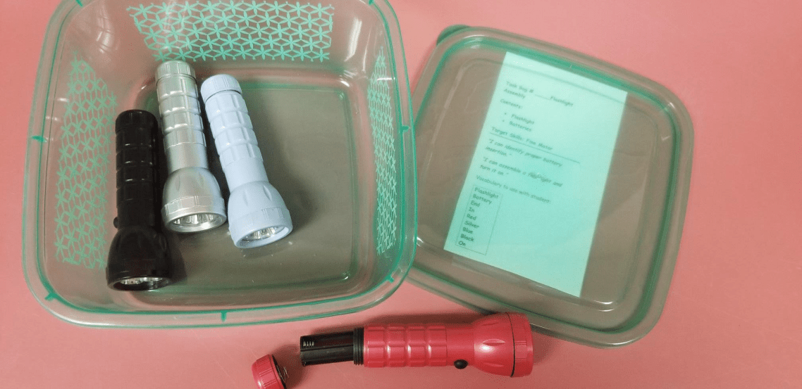

Task Bag #_____: Nut/Bolt Assembly
Contents:
- Nuts
- Bolts
Target Skills: Fine Motor/Life Skills
“I can identify a nut.”
“I can identify a bolt.”
“I can assemble a nut and bolt.”
Vocabulary to use with student:
Nut
Bolt
Together
Twist

Task Bag #_____: Coloured Block Match
Contents:
- Coloured foam blocks
- Colour trays
Target Skills: Readiness - Color Concepts
“I can name colours.”
“I can sort by color.”
Vocabulary to use with student:
Red
Yellow
Orange
Green
Sort
Line
In

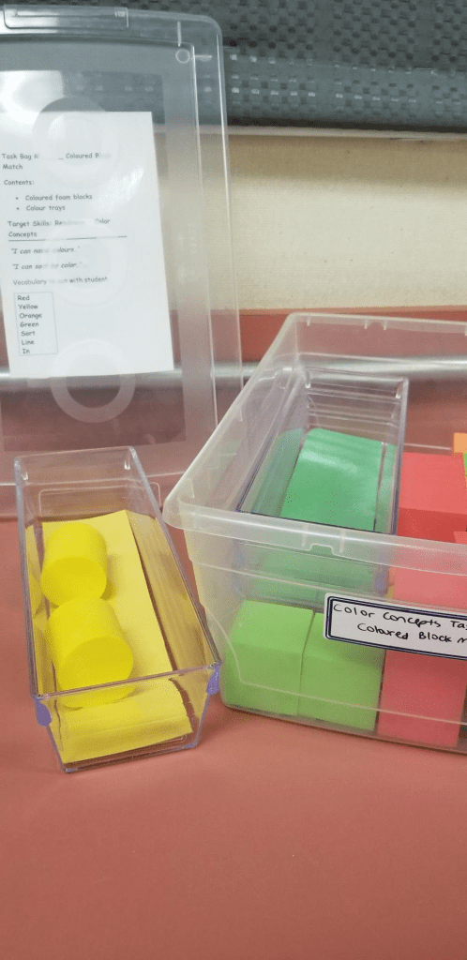

Task Bag #_____: Color Cut-Outs Sort
Contents:
- Yellow, green, and red Duplo blocks
- Lid with corresponding colors
Target Skills: Fine Motor Drop-In/Color Concepts
“I can sort by color.”
“I can name the colors.”
“I can drop-in.”
Vocabulary to use with student:
Yellow
Red
Green
Drop-In
Sort
Match

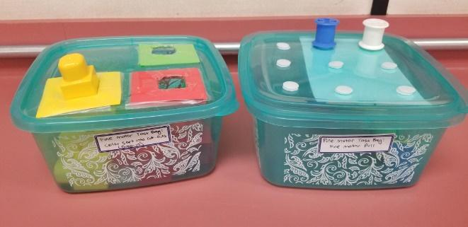

Task Bag #_____: Match by Color and Shape
Contents:
- Laminated shape template
- Laminated triangles, circles, and squares
Target Skills: Readiness – Matching by Visual Cue
“I can match by color.”
“I can match by shape.”
Vocabulary to use with student:
Red
Yellow
Blue
Triangle
Square
Circle
Match

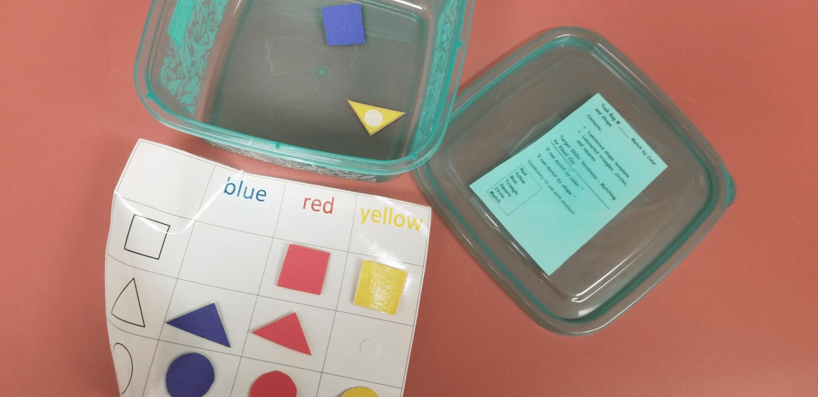

Task Bag #_____: Math Counting Match
Contents:
- Number puzzle pieces x2
Target Skills: 1-1 Correspondence/Counting
“I can count to 10.”
“I can match the number to the correct amount.”
Vocabulary to use with student:
Numbers 1-10
Count
Match

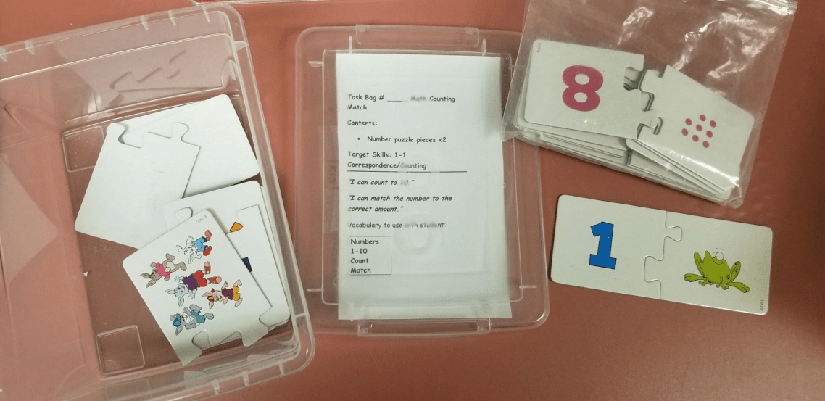

Task Bag #_____: Numeral Match
Contents:
- Red cups
- Small wooden cubes (9)
Target Skills: Matching Numerals and Sets
“I can count out objects to match a numeral.”
Vocabulary to use with students:
Count
How many?
0, 1, 2, 3, 4, 5, 6, 7, 8, 9

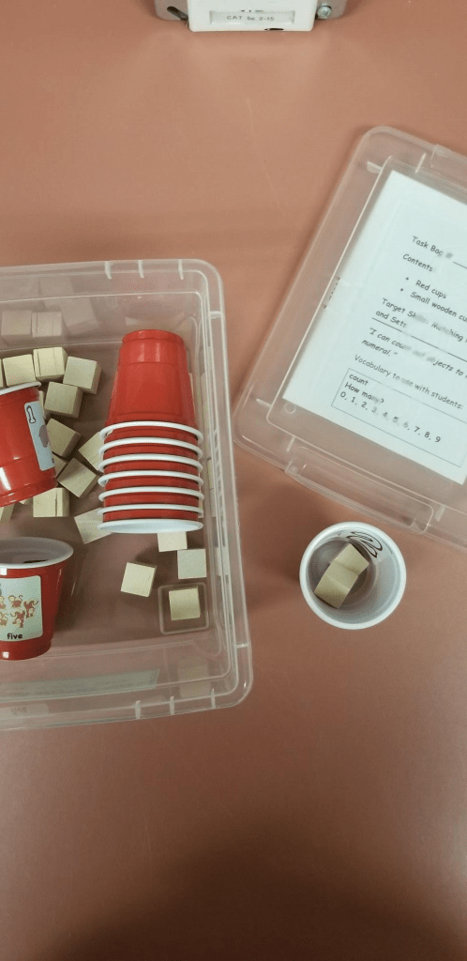

Task Bag #_____: Patterning
Contents:
- Yellow, blue, and red pegs
- Blue foam board
Target Skills: Patterning/Sorting by Color/Counting
“I can count.”
“I can create and copy patterns.”
“I can match like colors.”
Vocabulary to use with student:
Count
Numbers 1-10
Red
Yellow
Blue
Pattern

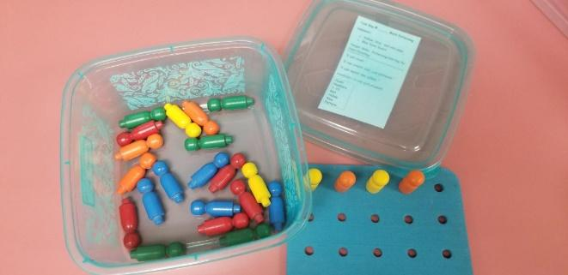

Additional ideas found at http://msgorhamsabcs.ca/inclusive-practices/task-bag-learning/
Math 1:1 Correspondence Trays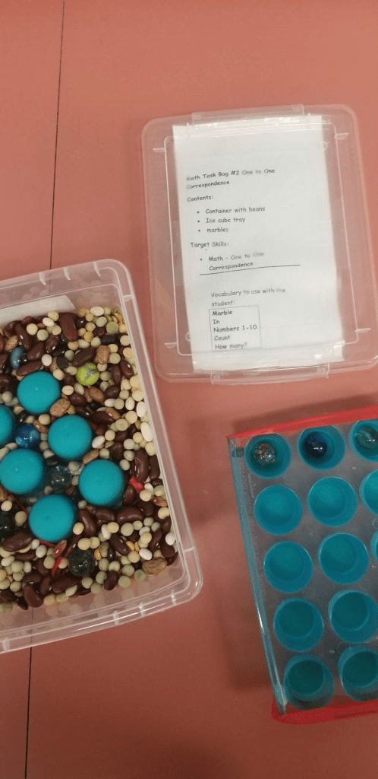
Magnetic Numbers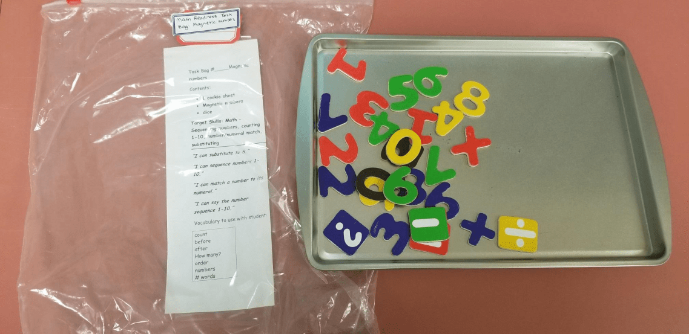 Creating, Replicating, and Extending Patterns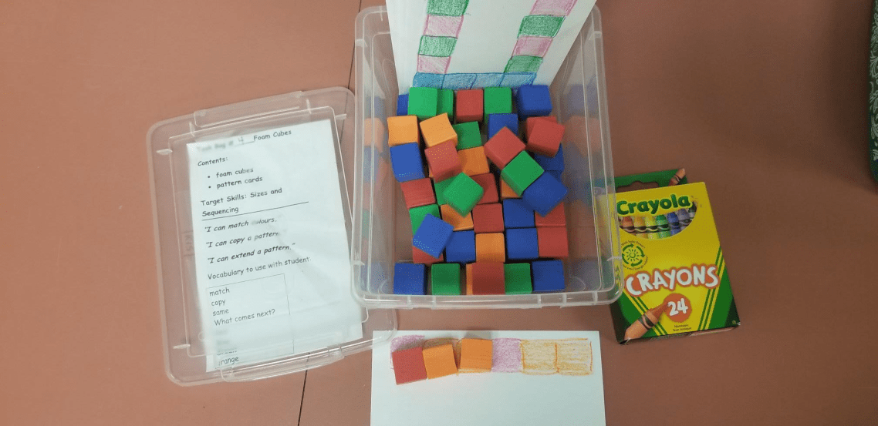 Clothing Sort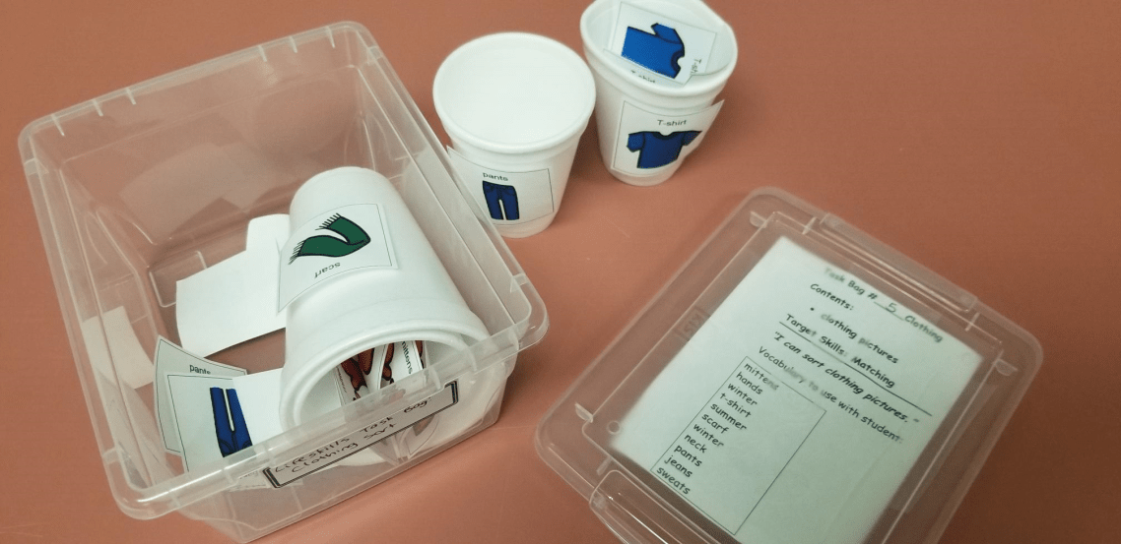
Math 1:1 Correspondence Cubes
Math Clip and Count the Chips 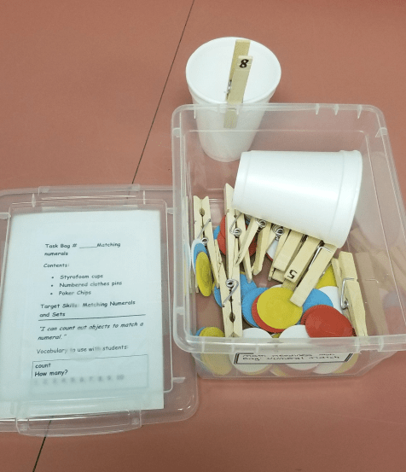
Healthy Choices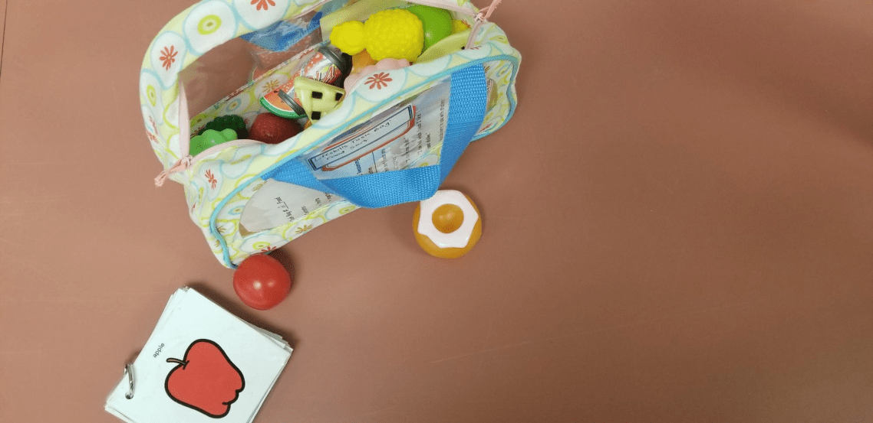
Life Skills 